# Lab 2. DC MOTOR DRIVE MODELLING

**Name:Li Xin**

**ITMO ID:375334**

## Specialization: Automation

## Objective

To get acquainted with modelling of speed/torque characteristic, of braking modes and of speed control of the DC motor in the Simulink software environment.

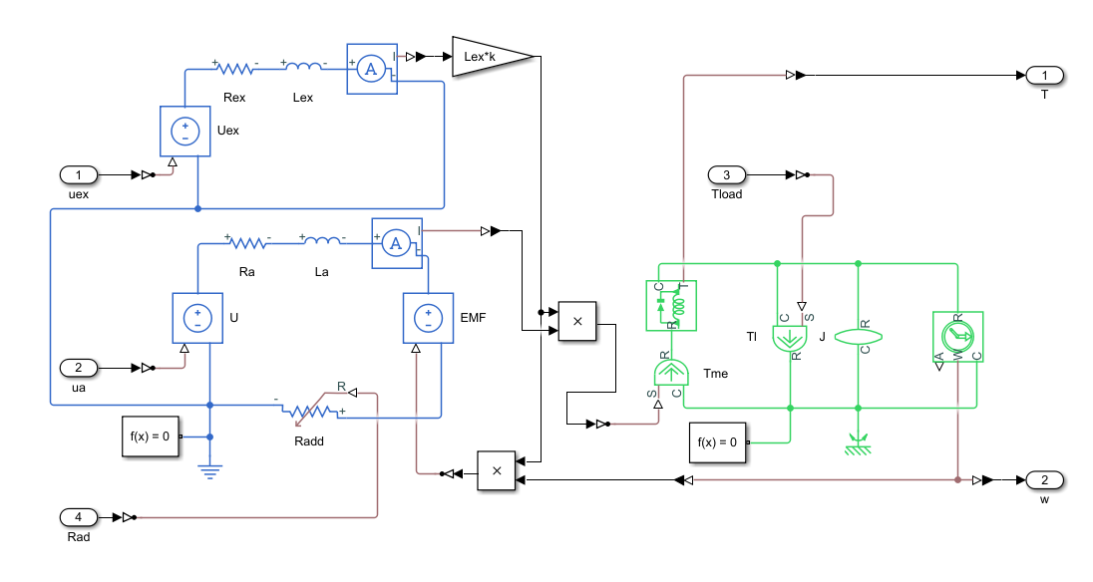

Figure 1. Simulation scheme of the electromechanical system DC motor – mechanical load.

## Initial data

|  |  |  |  |  |  |  |  |  |
| --- | --- | --- | --- | --- | --- | --- | --- | --- |
| **Parameter** | ***Ra*** | ***La*** | ***Rex*** | ***Lex*** | ***Iamax*** | ***k*** | ***J*** | ***Tload*** |
| **Value** | **10.9238 Ohm** | **32.1 mH** | **1.05 Ohm** | **200.9 mH** | **9 A** | **0.0982** | **10.7374 kg∙m2** | **2.1 Nm** |

**1. Build a simulation circuit.**

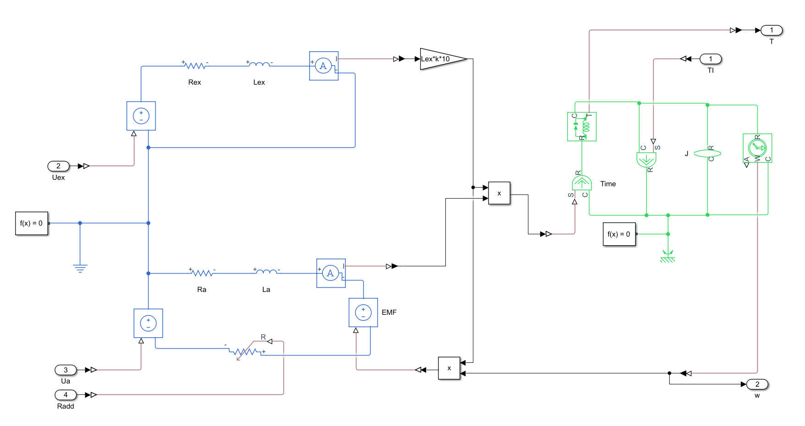

**Figure 2.** Simulation circuit.

**2. Simulation of natural and artificial speed/torque characteristics of DC motor.**

* 1. Speed control of the DC motor by changing armature voltage (*Unom*, 0.8*Unom*, 0.6*Unom*, 0.4*Unom*, 0.2*Unom*).

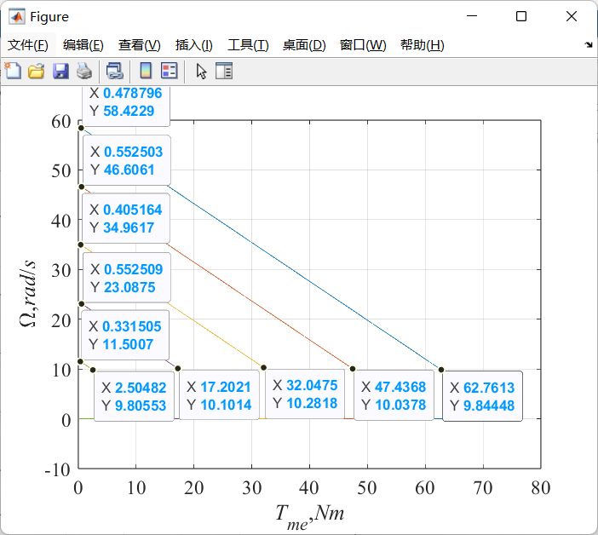.

**Figure 3.** Speed control of the DC motor by changing armature voltage.

* 1. Speed control of the DC motor by changing the magnetic flux (*Uex*, 0.8*Uex*, 0.6*Uex*, 0.4*Uex*, 0.2*Uex*).

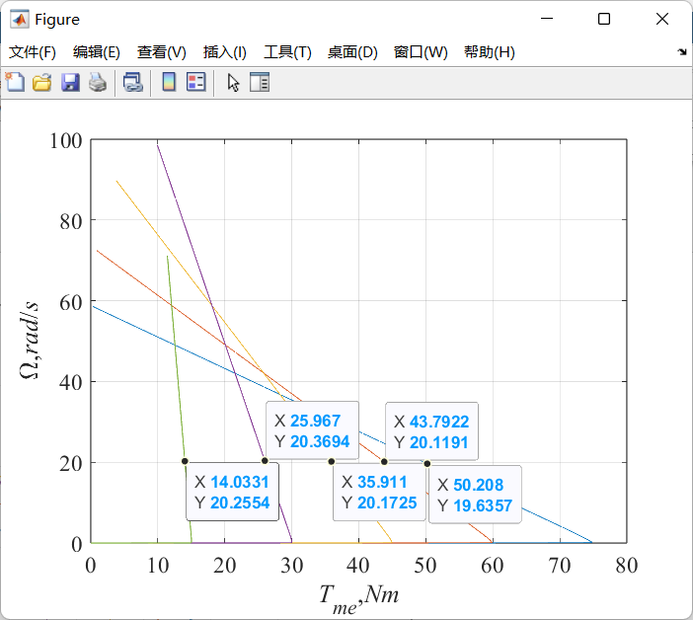

**Figure 4.** Speed control of the DC motor by changing the magnetic flux.

**3. Simulation of braking modes.**

1. Simulation of reverse braking by adding resistance *Radd*.

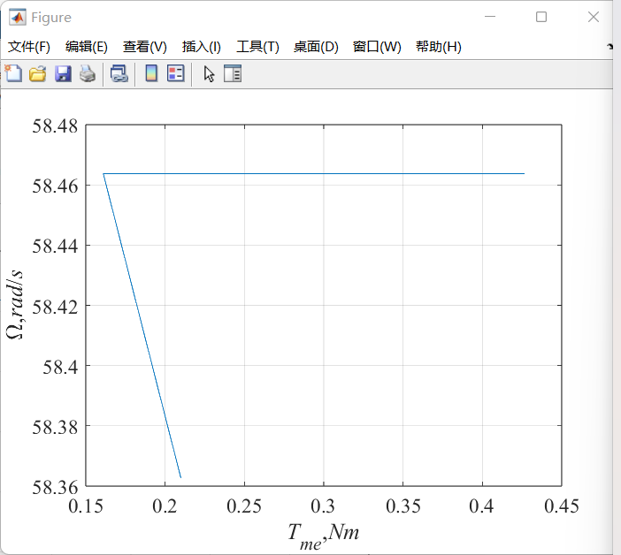

**Figure 5.** Reverse braking.

1. Simulation of dynamic braking by disconnecting converter and connecting resistance Radd.

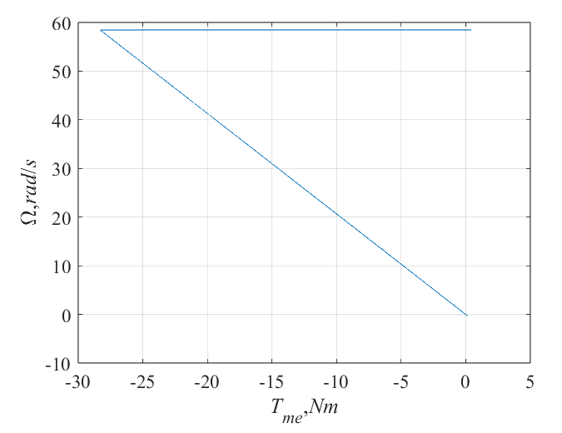

**Figure 6.** Dynamic braking.

1. Simulation of regenerative braking by changing armature voltage from Unom to 0.8Unom.

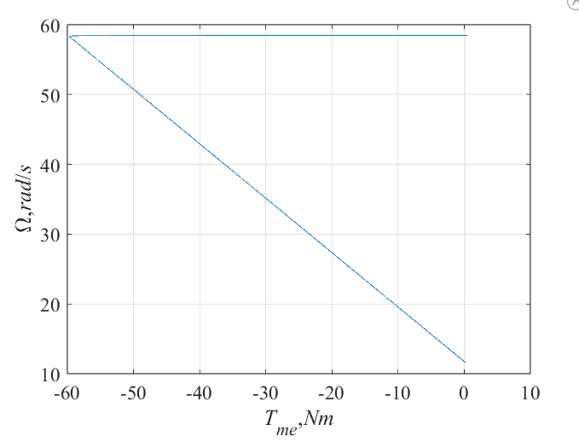

**Figure 7.** Regenerative braking.

**4. Simulation of starting of the DC motor.**

1. Simulation of direct starting of the DC motor.

*Iinr* = 22.8 A > *Imax*

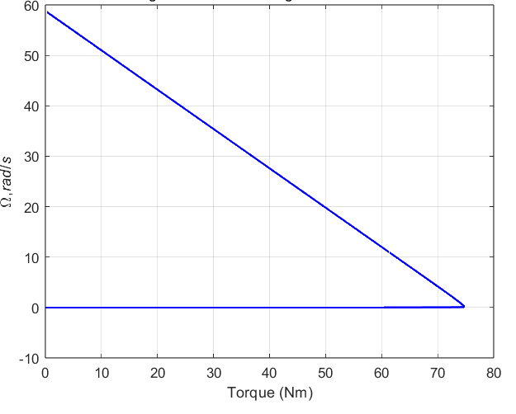

**Figure 8.** Direct starting of the DC motor.

1. Simulation of starting of the DC motor with additional resistances *R*1, *R*2, *R*3. Armature current *Ia*must be lesser then maximum value *Iamax*.

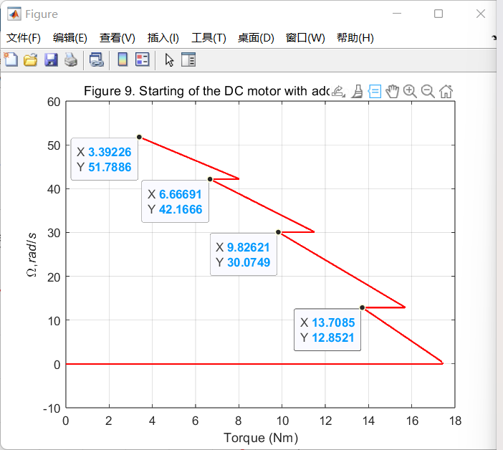.

**Figure 9.** Starting of the DC motor with additional resistances.

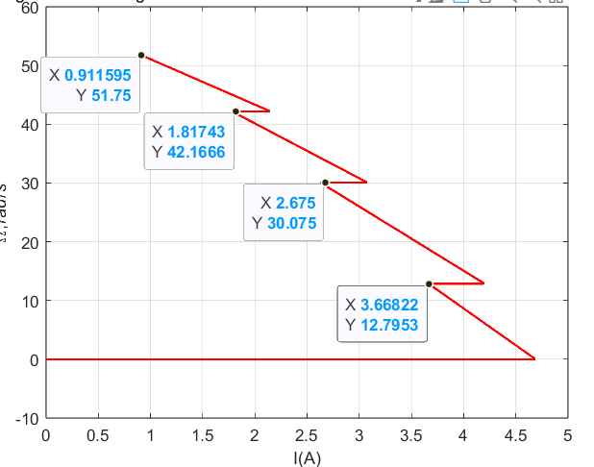.

**Figure 10.** Starting of the DC motor with additional resistances (speed/current).

1. **Conclusion**

**I**n this laboratory work, a comprehensive Simulink model of a DC motor system was developed and analyzed. Various aspects of motor behavior were studied, including speed/torque characteristics, speed regulation techniques, braking strategies, and different starting approaches. Speed control was effectively implemented through adjustments in both armature voltage and magnetic flux, which aligned well with theoretical expectations. The braking modes explored—reverse, dynamic, and regenerative—demonstrated different performance characteristics, with regenerative braking standing out due to its energy-saving potential. Direct motor startup resulted in excessive inrush current, exceeding the maximum permissible value, which was successfully mitigated by incorporating external resistors. Overall, the simulations provided clear validation of theoretical principles and offered practical insights into the efficient and safe operation of DC motors.